# Team Members

|  |  |
| --- | --- |
| Name | Student ID |
| Yuheng (Hugh) Song | A00971421 |
| Liang (Victor) Zhao | A00936830 |
| Mingkai (Benjamin) Hao | A00955382 |
| Hai Hua (Ryan) Tan | A00950721 |
| Tse-kuang (Ebon) Chung | A00971903 |

# Milestone3

# List of items completed for this milestone

* All the page’s structure and css including one Home page and four sub-home pages
* Create external style base.css for all the pages and individual style for our pages
* Use JavaScript on navigation and home page
* Choose pictures and edit them for our pages
* Create user input form in contact us page and use table element in our pages
* Link the submit button to the pages which will show information have been recived
* Validate the html and css in different browser
* A/B test for the color and picture choose

# Additional work

We use javascript in the navigation part and the gallery part in our home page, and we try to fix some

javascript problem in our web pages.

# Issues in the milestone

We have some problem about the position of element, some of them have fixed and some of them have not yet. We will fix that continue.Appendix

# Screenshot for the front pages and the form page

## Home page

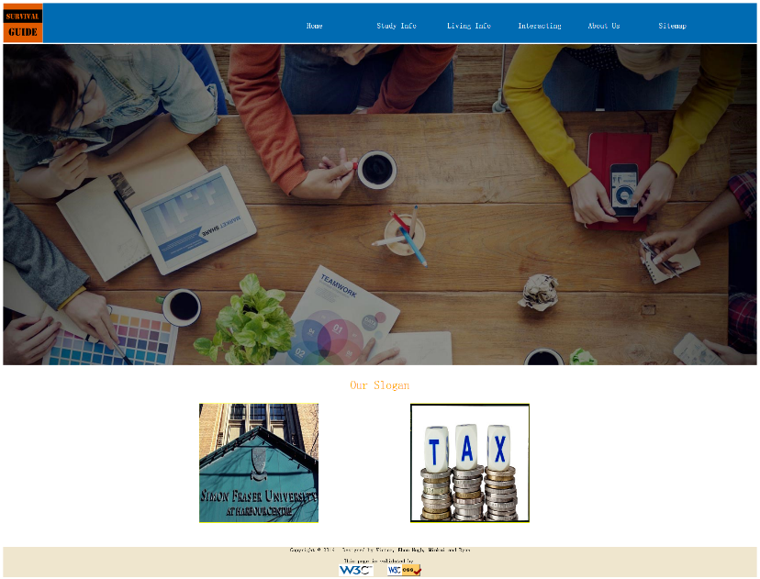

## Sub-home pages

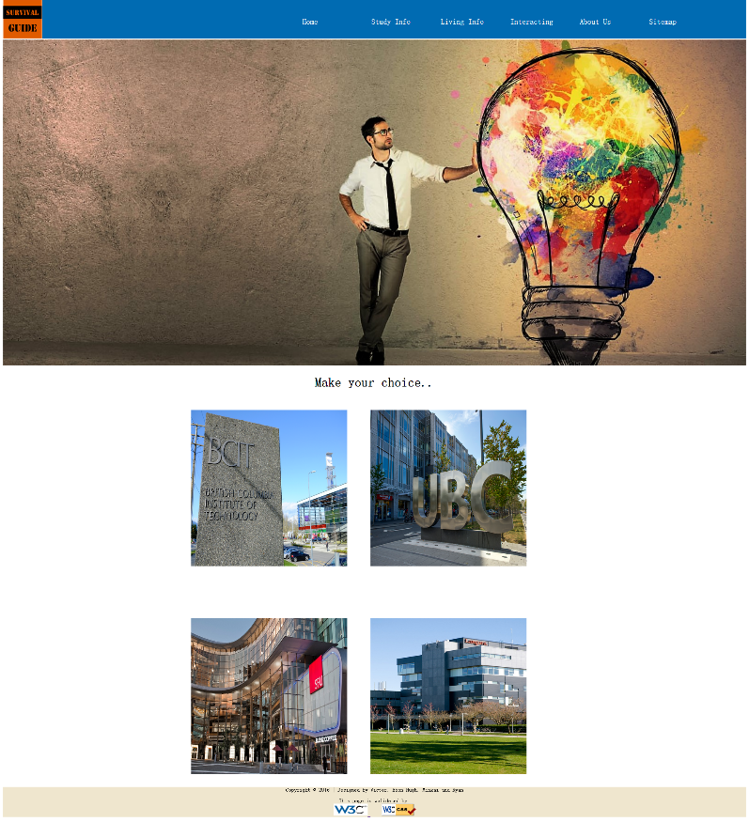

Schools

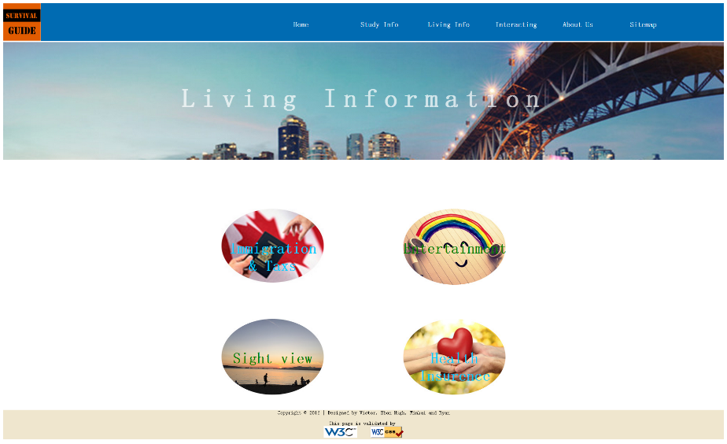

Living info

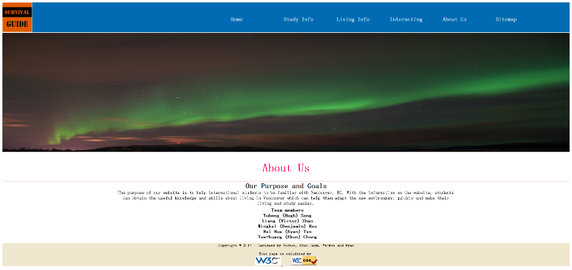

About us

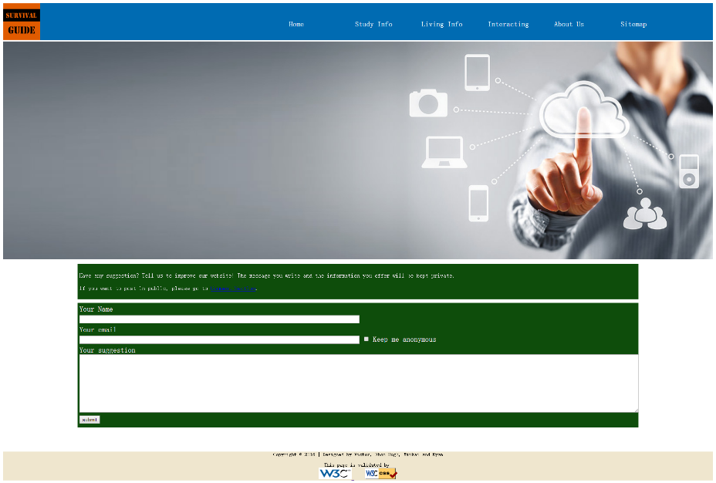

Contact us

# Milestone2

# Layout Design

## Site Map

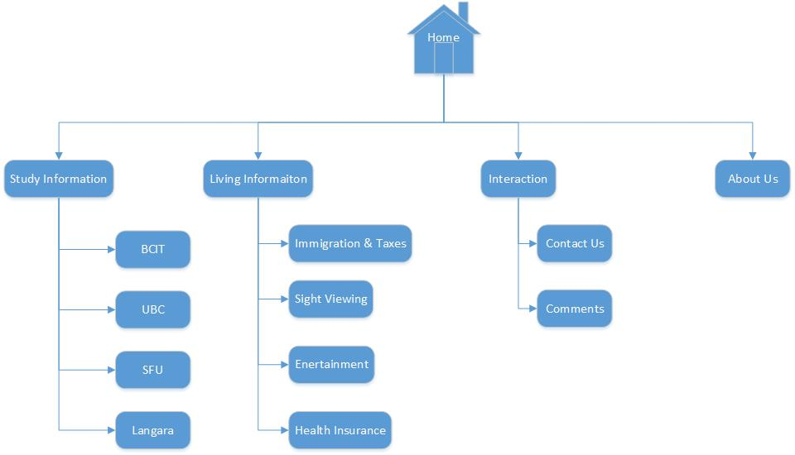

## Layout

This is our Home page lay out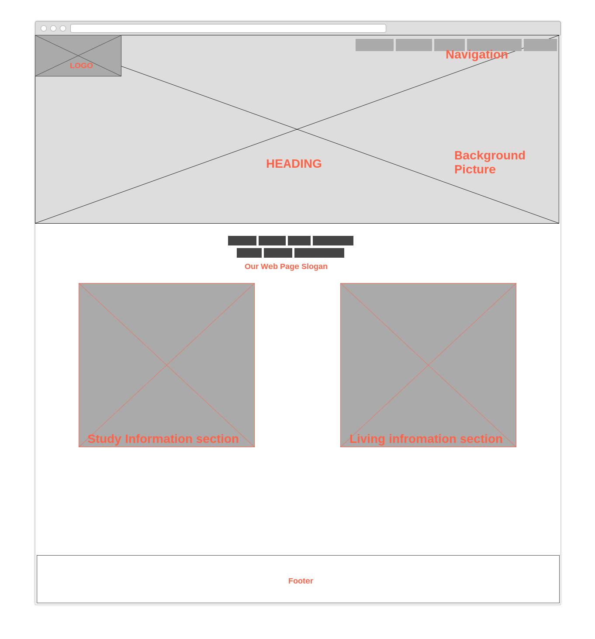

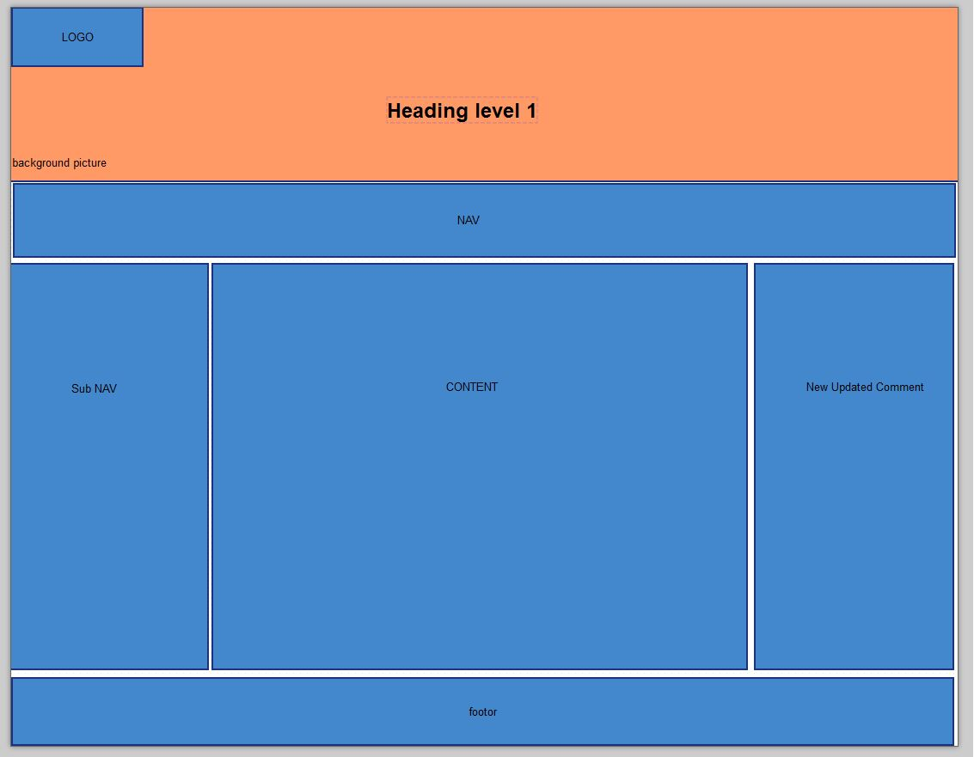

Other content pages will base on this layout because same structure can help readers to find the same types of data and compare the data.

# Print Layout of home page

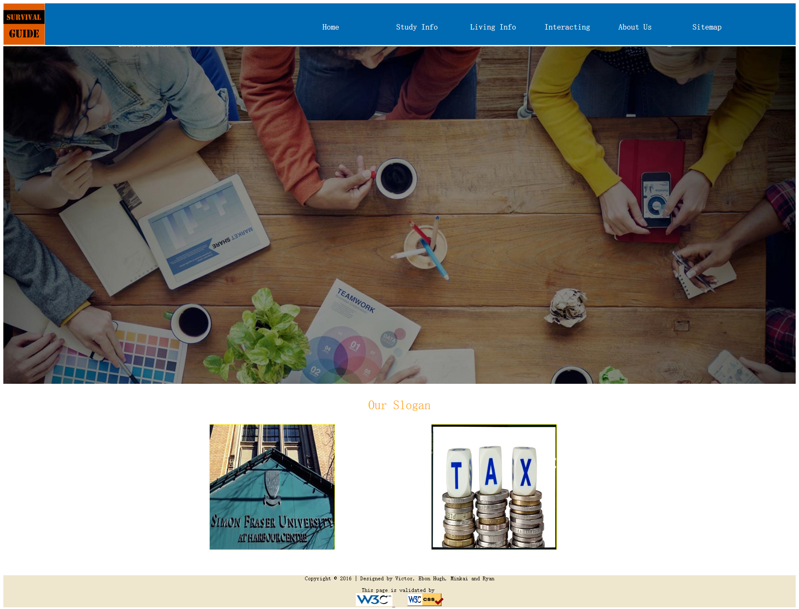

## Color Choose

Background color: Black

Text color: White

We choose big picture as our background, so we want to use black for our background color which can make our page clearer and simple. We also use white as the texts color because the white have a strong contrast with black and people can easily see the important messages.

## Design Reason

We use the big picture which can make people see our information more directly, they don’t need to see a lot of words to find what they want. And we try to use simple words as our tags and headings to guide people to the right place of the information. Also, we have many hyperlinks with images, people can easily find the right place. The all ideas based on our core purpose that give people accurate guidance.

# Milestone1

Background   
Many students are often struggling when they need to make a decision among tons of information from various sources which may or may not be true. Our website is dedicated to provide accessibility of useful, accurate information for international students.

Purpose and Goals  
The purpose of our website is to help international students to be familiar with Vancouver, BC. With the information on the website, students can obtain the useful knowledge and skills about living in Vancouver which can help them adapt the new environment quickly and make their living and study easier.

# Target Audience

* International students
* Visitors and travelers
* People who are planning to come to Vancouver
* Institutions and agencies

# Objectives

Our website will accomplish three main functionalities:

* Study information section

Our website collects the application information, introduction of schools, and school-choosing suggestion in this section. Students can also share their own experiences in applying schools.

* Living information section:

The website gathers the most useful living information to help international students to adapt to their new lives, including food, transportation, accommodation and interesting places in the city. Students can also learn some Canadian culture in this section.

* Communicating section

The website provides a platform for students to be connected with the people who they may want to know.

# Type of Content

The website will employ various types of element to make an attractive presentation of the content.

* Text

Text is used to describe the basic information. To make a neat and comfortable looking, different fonts, headings, div, span will be combined in our website. Meanwhile, some wordarts will be added to producing an appealing impression.

* Pictures & Graphics

Pictures and graphics are used as needed to enrich the visual effect of our website. In case of showing numbers, different kinds of charts will be applied.

* Audio & video

To better demonstrate some topics, Audio and video elements will be utilized in our website. Background music is a consideration of our website to create a comfortable user experience.

# Success Factors

Our website will be differentiated from other websites for 3 main characteristics.

* First-hand information

We provide accurate and up-to-date information. Most team members are also international students who know the demands very well.

* Interactive communication

The website will offer Q&A service for students to ask question. The audience can make comments or answer questions posted in the website.

* A bridge to get connected

The website enlarges the chance for students to get in touch with people in the schools they are planning to apply.

# Web Sources Preview

We looked up the international student section from SFU’s and UBC’s websites and compared the differences between these two websites. On SFU’s website, the section is divided into two categories for the different people with a clear structure. In the case of UBC, there are abundant hyperlinks on the home page to guide students to different fields. We tend to build an organized and logical webpage, and we use the hyperlinks to help the readers to access other pages.

# Functional requirements

* Form requirement

Forms will be appled in the case of user submitting posts to our message board.

* List requirement

A sitemap includes the overview of our website will be demonstrated as a list. Tables will also be used to show structured information. An example of table in living section may be as below:

|  |  |  |  |
| --- | --- | --- | --- |
| Restaurant | Address | Average price | Rating |
|  |  |  |  |
|  |  |  |  |

# Work plan

To assure the project to meet the dead lines, the team agrees on the following approches:

* A time table will be created base on the milestone of the project.
* The project will be separated into different modules and assign to specific members.
* Regular meeting will be held every week to check the progress and solve problems.
* An IM group is established for discussing when needed.

# References

International Student Guide. (n.d.). The University of British Columbia. Retrieved from: http://students.ubc.

ca/international

SFU International. (n.d.). Simon Fraser University. Retrieved from: http://www.sfu.ca/international.html

Wireframe tool: https://wireframe.cc/